**Test Instruction**

Prior to formal printing, manual unilateral debugging is required to test the normal operation of each component. The inadvertent assembly and connection problems in previous steps can be tested and resolved in the step-by-step debugging steps.  
In general, you need to test the following:  
1.Whether the motor running normally or not，that means the platform automatically home normally or not.  
2. Whether the nozzle and hot bed heating are normal, can reach the preset temperature or not and the control is stable;  
3. Whether the platform is adjusted well, the general platform and the nozzle just contact, there is a slight scratch.  
Note: unilateral debugging involves the integrated control of software, hardware and machinery and is the coordinating work of the entire electromechanical system. If you encounter problems in the debugging process, you need to consult relevant manuals for analysis and understanding. If you have any difficulties, please contact with the customer service.

**Step 1: Test the direction of each axis**

Here is the test of the machine through the LCD screen. First of all, please check the LCD screen comments;  
1. Select "Prepare" "Auto-home", each axis will return to the origin (lower left corner position), and the limit switch stops, indicating that the direction is correct.

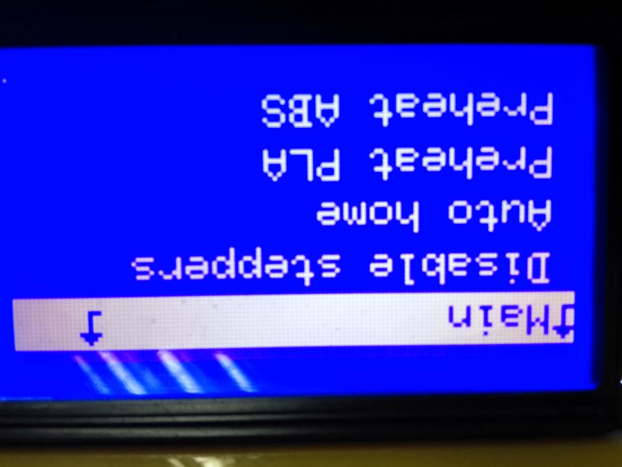

Select "disable steppers", the motor can rotate freely. After returning to zero, you can manually slide the nozzle to level.



**Step 2: Preheat the nozzle**

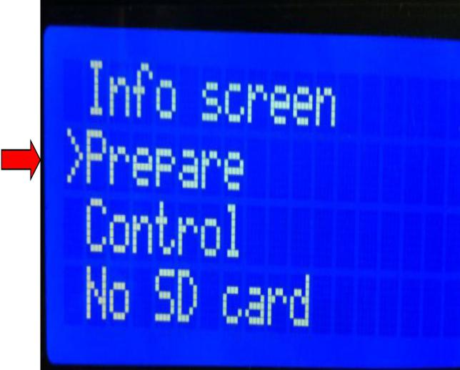



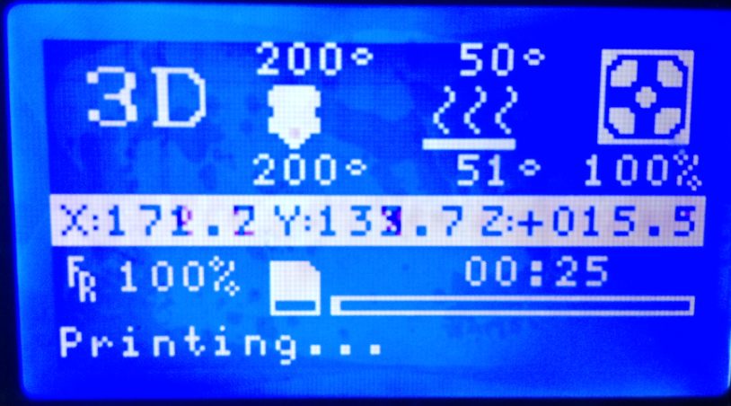

(On the top is the preset temperature, on the button is the actual temperature)  
**Step 3: Leveling**  
Machine leveling is very important and directly related to the effect of printing. Well leveling before printing, you don’t have to adjust it when post-printing.  
1. Press the control knob to select "Prepare" -> "Leveling"

Main

Auto home

Moving axis

Disable steppers

**☞**leveling

Info screen

**☞**Prepare

Control

No SD card

2. After selecting the "leveling" command, according to the screen prompts, the nozzle will move to the four corners of the platform in order, horizontally observe the distance between the platform and the nozzle, and adjust the distance between the nozzle and the platform through the knob under the platform. Just can put A4 paper between them. After the adjustment, select "Auto-home" "disable steppers" and when moving the nozzle manually, there are shallow scratches on the A4 paper.

Main

Auto home

Moving axis

Main

**☞**Auto home

Moving axis

Prepare

**☞**Next

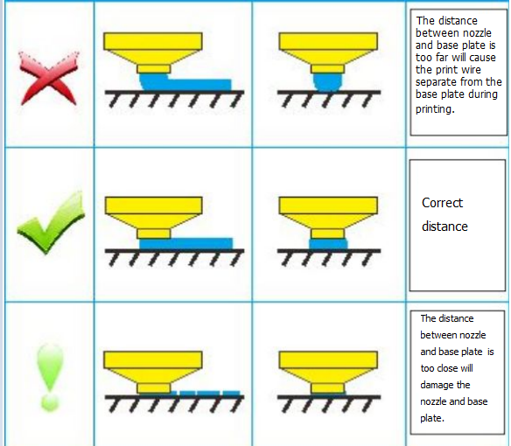

Turning the knob clockwise means reducing the distance between the nozzle and the platform to make the two more close; rotating the knob counterclockwise means increasing the distance between the nozzle and the platform to keep the two away. Remember to lightly tighten / loosen the screws. Adjust them by rotating a little bit.

